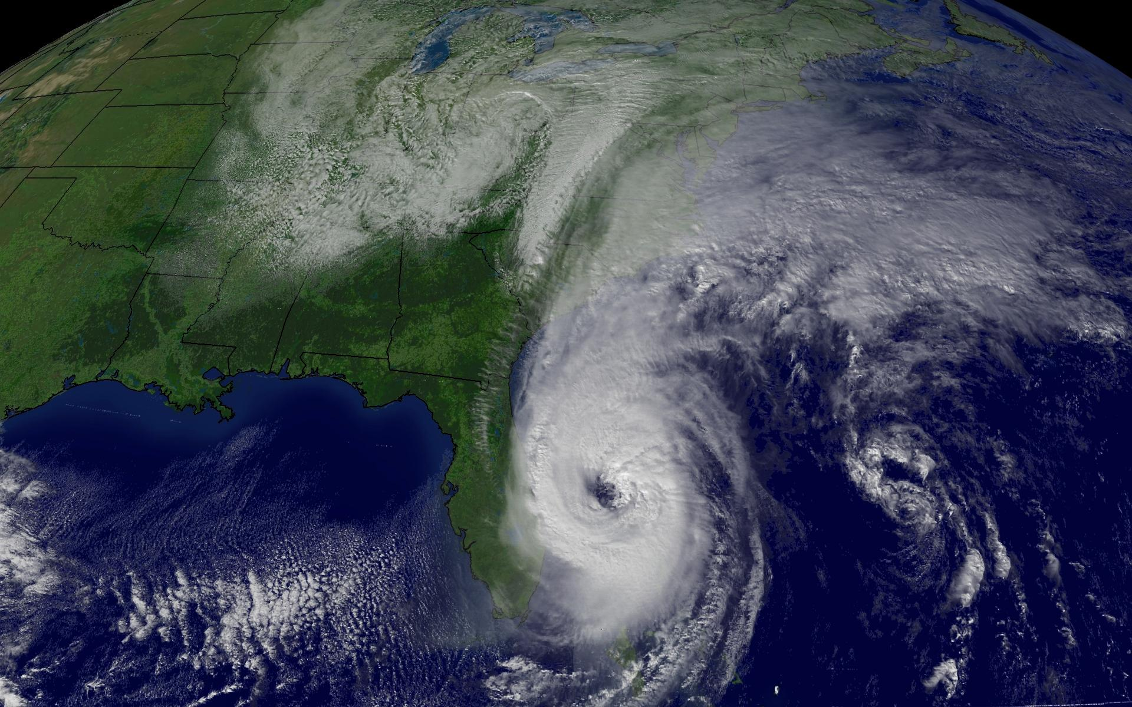  - {Enter HurricanE Name}  {Enter Fund Name}  How you can help!  With {Enter # of Employees} in the storm’s path, the number of families impacted continues to grow with some in need of critical survival needs such as shelter, food, and clothing.  The best way to show support to those impacted is to donate to the {Enter Fund Name} which was created to help employees who are facing financial hardship immediately after a natural disaster or an unforeseen personal hardship.  The {Enter Fund Name relies primarily on individual donations from employees and support from {Enter Company Name} to fund this program. | Ways to Give  On the Web  Set up a one-time donation by check, debit, credit card, or PayPal. Website- {Insert URL}  ____  Payroll Deductions  Set up recurring donations through a payroll deduction. {Enter URL or instructions for form}  ____  Text-to-Give  Set up a one-time donation by check, debit, credit card, or PayPal right from your Smartphone! Text {Enter Code} to {Enter #} to get started!  Enter Code  Enter #

